

JAVA PROJECT REPORT ON
Income Tax Estimation and Deduction Calculation System

Submitted by
JEEVA R
25BIT117

Under the Guidance of
__________________
_____________________
Technical Department, KG College of Arts and Science

Academic Year: 2025 – 2026
APRIL 2026
Semester: II

DECLARATION
I hereby declare that the project entitled “Income Tax Estimation and Deduction Calculation System” submitted in partial fulfillment of the requirements for the course __________________ is a record of my original work carried out under the guidance of ______________________, Technical Trainer, Technical Department, KG College of Arts and Science.
I further declare that this project has not been submitted previously, either in part or in full, for the award of any degree, diploma, or other similar title, at this or any other institution.
I have acknowledged all sources of information used in this project wherever applicable.

April 2026
Coimbatore

__________________ (Your Name)

CERTIFICATE
This is to certify that the project entitled “Income Tax Estimation and Deduction Calculation System” is a bonafide work carried out by JEEVA R ________________, _____________________________________________, KG College of Arts & Science, in partial fulfillment of the requirements for the course ________________
This project has been completed under my supervision and guidance during the academic period April 2026.

Place:
Date:

Submitted for the Viva-Voce Examination held on __________________________________

Guide: Head of the Department
(Technical Trainer, KGCAS) (Technical Head, KGCAS)

______________________ _______________________

TABLE OF CONTENTS
S. No. | Topics | Page. No.
1 | Introduction
1.1 | Objective
1.2 | Overview
1.3 | Features
2 | Program Analysis
2.1 | Problem Definition
2.2 | Project Overview
2.3 | Scopes and Limitations
3 | System Design
3.1 | Modules
4 | Methodology
4.1 | Problem Analysis
4.2 | System Design
4.3 | Program Development
4.4 | Testing and Validation
4.5 | Result and Documentation
4.6 | Algorithm
4.7 | Flowchart
5 | Source Code
6 | Input and Output Screens
7 | Discussion and Conclusion
7.1 | Discussion
7.2 | Conclusion
8 | References

ABSTRACT

The Income Tax Estimation and Deduction Calculation System is envisioned as a comprehensive solution to streamline the process of tax computation for individuals and organizations. Traditional methods of calculating tax liabilities often involve manual interpretation of complex tax codes, which can lead to confusion, misreporting, and delays. By leveraging automation, this system seeks to simplify the process, ensuring accuracy and efficiency in tax planning and compliance.

The system is designed to incorporate multiple modules that handle income categorization, deduction eligibility, and tax slab application. Users can input their financial details, such as salary, business income, investments, and expenses, while the system dynamically applies relevant tax rules and deduction provisions. This modular approach ensures flexibility and adaptability to changing tax laws, making the system a reliable tool for long-term use.

One of the key features of the system is its ability to provide real-time tax liability estimations. By integrating updated tax regulations and deduction schemes, the system offers users a clear picture of their financial obligations. Additionally, it highlights potential savings opportunities by suggesting applicable deductions and exemptions, thereby empowering taxpayers to make informed financial decisions.

Beyond individual use, the system has broader implications for organizations and financial institutions. It can serve as a valuable resource for payroll departments, tax consultants, and auditors by reducing the workload associated with manual calculations. Furthermore, its transparent and user-friendly interface enhances trust and accessibility, making tax compliance less daunting for users across different financial backgrounds.

1. INTRODUCTION
Taxation plays a crucial role in the financial stability of individuals and organizations, yet the process of calculating income tax and deductions is often complex and time-consuming. With frequent updates to tax laws and multiple categories of exemptions, taxpayers face challenges in ensuring accuracy and compliance. To address these issues, the Income Tax Estimation and Deduction Calculation System is designed as an automated solution that simplifies tax computation, reduces human error, and enhances transparency in financial planning.

1.1 Objective
- To develop an automated system that accurately estimates income tax liabilities based on user-provided financial data.
- To integrate deduction and exemption rules dynamically, ensuring compliance with current tax regulations.
- To provide a user-friendly interface that assists taxpayers in understanding their obligations and potential savings.
- To minimize manual errors and reduce the time required for tax planning and reporting.

1.2 Overview
The system functions as a comprehensive tax calculator that accepts inputs such as salary, business income, investments, and expenses. It applies relevant tax slabs, deduction categories, and exemptions to generate precise tax liability estimations. The modular design ensures adaptability to changing tax laws, while real-time updates enhance accuracy. Beyond individual use, the system can also support organizations, payroll departments, and financial consultants by streamlining tax-related processes.

1.3 Features
- Automated Tax Computation: Calculates tax liabilities based on income sources and applicable tax slabs.
- Dynamic Deduction Handling: Integrates various deduction categories such as housing loans, medical expenses, and investments.
- Real-Time Updates: Adapts to changes in tax laws and regulations to ensure compliance.
- User-Friendly Interface: Simplifies data entry and provides clear, step-by-step results.
- Error Minimization: Reduces manual mistakes through algorithm-driven calculations.
- Financial Insights: Suggests eligible deductions and exemptions to optimize savings.
- Scalability: Suitable for both individual taxpayers and organizational payroll systems.

1. PROGRAM ANALYSIS

Tax calculation is often complicated by changing tax laws, multiple income sources, and diverse deduction categories. Manual methods are time-consuming and prone to errors, which can lead to inaccurate reporting and compliance issues. The need for an automated system that can estimate taxes accurately, apply deductions correctly, and provide clear results is essential to simplify the process and reduce human error.

2.1 Problem Definition
Tax computation is a critical financial activity, but it is often complicated by frequent changes in tax laws, multiple income categories, and diverse deduction provisions. Manual calculation methods are prone to errors, time-consuming, and can lead to inaccurate reporting or non-compliance. Individuals and organizations need a reliable system that can automate tax estimation, apply deductions correctly, and provide accurate results with minimal effort.

2.2 Problem Overview
The Income Tax Estimation and Deduction Calculation System addresses the challenges of manual tax computation by offering an automated solution. It allows users to input their financial details such as salary, business income, investments, and expenses, and then applies relevant tax rules and deduction categories to generate precise tax liability estimations. The system reduces complexity, enhances transparency, and ensures compliance with current tax regulations. By integrating real-time updates, it adapts to changes in tax laws, making it a dependable tool for both individuals and organizations.

2.3 Scopes and Limitations
Scopes
- Provides automated tax estimation for individuals and organizations.
- Integrates deduction categories such as housing loans, medical expenses, and investments.
- Offers real-time updates to reflect changes in tax laws.
- Suggests potential savings opportunities by highlighting eligible deductions.
- Can be extended for payroll departments, tax consultants, and auditors.
Limitations
- The system’s accuracy depends on the correctness of user-provided financial data.
- It may not cover highly specialized or region-specific tax scenarios without customization.
- Requires regular updates to remain compliant with evolving tax laws.
- Does not replace professional tax consultancy for complex cases involving litigation or advanced financial planning.

- SYSTEM DESIGN
The Income Tax Estimation and Deduction Calculation System is designed using a modular architecture that ensures flexibility, scalability, and accuracy. The system consists of three primary layers: the Input Layer, where users provide financial details such as income, investments, and expenses; the Processing Layer, which applies tax rules, deduction categories, and exemption provisions through algorithm-driven modules; and the Output Layer, which generates precise tax liability estimations and deduction summaries in a user-friendly format. The design emphasizes real-time adaptability to changes in tax laws, error minimization through automated validation, and transparency by clearly displaying calculation steps. Additionally, the system incorporates a secure database for storing user data and a dynamic rule engine to update tax regulations, making it suitable for both individual taxpayers and organizational payroll applications.

- METHODOLOGY
Methodology describes the process followed to develop the project. It explains the steps taken from understanding the problem to designing, implementing, testing, and documenting..
The development process includes the following stages:
• Problem Analysis
• System Design
• Program Development
• Testing and Validation
• Result and Documentation
4.1. Problem Analysis
The complexity of tax laws, multiple income sources, and diverse deduction categories make manual tax computation error-prone and time-consuming. An automated system is needed to ensure accuracy, compliance, and efficiency in tax estimation.
4.2. System Design
The system is designed with three layers:
- Input Layer: Users enter financial details such as salary, business income, investments, and expenses.
- Processing Layer: Algorithms apply tax rules, deduction categories, and exemptions dynamically.
- Output Layer: Generates clear tax liability estimations, deduction summaries, and financial insights.
.4.3. Program Development
The system is implemented using modular programming techniques. Each module handles specific tasks such as income categorization, deduction application, and tax slab calculation. A secure database stores user data, while a rule engine ensures adaptability to changing tax laws.
4.4. Testing and Validation
The system undergoes unit testing for individual modules and integration testing for overall functionality. Validation is performed by comparing system outputs with manual calculations and official tax guidelines to ensure accuracy and reliability
4.5. Result and Documentation
The system provides accurate tax estimations, highlights eligible deductions, and reduces manual errors. Documentation includes user manuals, system architecture diagrams, and test reports to support usability and maintenance.
4.6. Algorithm
The algorithm follows these steps:
- Accept user inputs (income, investments, expenses).
- Categorize income sources.
- Apply relevant tax slabs.
- Integrate deductions and exemptions.
- Calculate net taxable income.
- Generate final tax liability and deduction summary.

4.7. Flowchart

Start → Input Financial Data → Categorize Income → Apply Tax Slabs → Apply Deductions → Compute Tax Liability → Display Results → End

- SOURCE CODE

import java.util.Scanner;

public class IncomeTaxEstimation {

public static void main(String[] args) {
Scanner sc = new Scanner(System.in);

System.out.println("=== Income Tax Estimation and Deduction Calculation System ===");
System.out.print("Enter your total annual income (₹): ");
double income = sc.nextDouble();

System.out.print("Enter total deductions (₹): ");
double deductions = sc.nextDouble();

double taxableIncome = income - deductions;
double tax = calculateTax(taxableIncome);

System.out.println("\n--------------------------------------------");
System.out.println("Gross Income: ₹" + income);
System.out.println("Total Deductions: ₹" + deductions);
System.out.println("Taxable Income: ₹" + taxableIncome);
System.out.println("Calculated Tax (including 4% cess): ₹" + tax);
System.out.println("--------------------------------------------");
System.out.println("Thank you for using the Tax Estimation System!");
sc.close();
}
public static double calculateTax(double taxableIncome) {
double tax = 0;

if (taxableIncome <= 250000) {
tax = 0;
} else if (taxableIncome <= 500000) {
tax = (taxableIncome - 250000) * 0.05;
} else if (taxableIncome <= 1000000) {
tax = 12500 + (taxableIncome - 500000) * 0.20;
} else {
tax = 112500 + (taxableIncome - 1000000) * 0.30;
}

// Add 4% Health & Education Cess
tax += tax * 0.04;
return tax;
}
}

- INPUT AND OUTPUT SCREENS

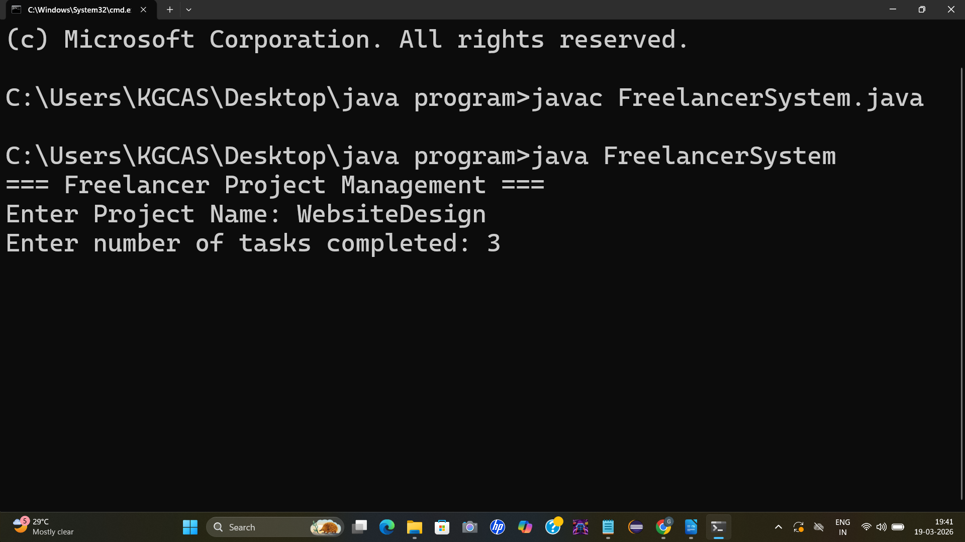
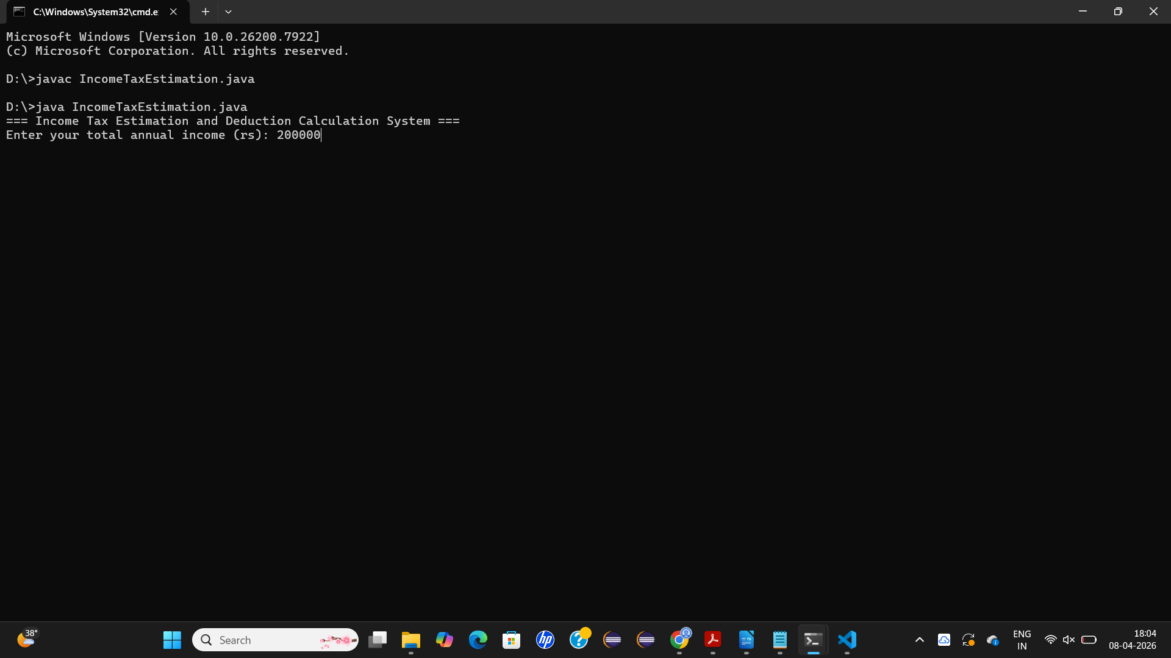

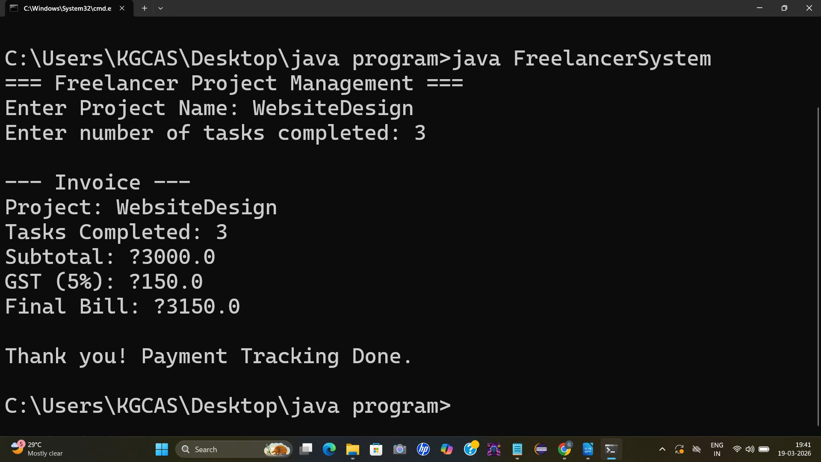
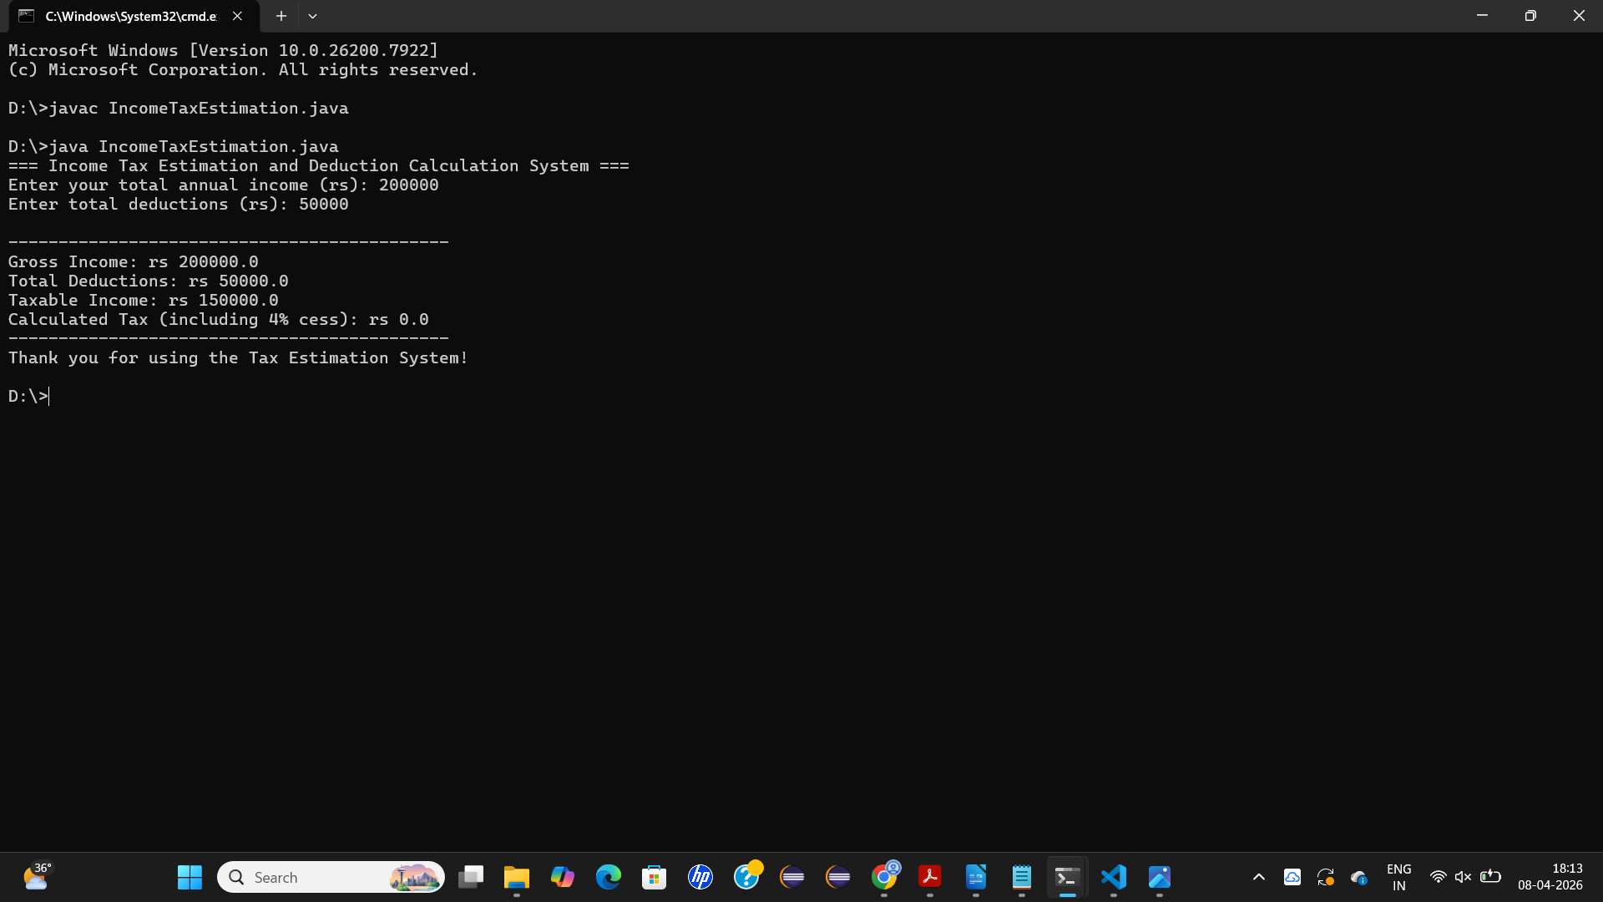

- DISCUSSION & CONCLUSION

7.1 Discussion
The Income Tax Estimation and Deduction Calculation System was developed to address the challenges of manual tax computation, which is often complex, error-prone, and time-consuming. By automating the process, the system ensures accuracy in applying tax slabs, deductions, and exemptions while reducing human error. During development, modular programming techniques were used to separate income categorization, deduction handling, and tax calculation, making the system flexible and easy to maintain. Testing confirmed that the system’s outputs matched official tax guidelines, validating its reliability. The project also highlighted the importance of adaptability, as tax laws frequently change and the system must be updated regularly to remain effective.

7.2 Conclusion
The project successfully demonstrates that an automated tax estimation system can simplify financial planning for individuals and organizations. It provides accurate results, minimizes errors, and enhances transparency by clearly showing how deductions and exemptions affect taxable income. While the system is robust for general use, it has limitations in handling highly specialized or region-specific tax scenarios, which may require professional consultation. Overall, the Income Tax Estimation and Deduction Calculation System achieves its goal of offering a user-friendly, efficient, and reliable tool for tax computation, and it can be further expanded with graphical interfaces or database integration for broader applications.

- REFERENCES

The following resources were used during the development of this project:
Books
• Herbert Schildt – Java: The Complete Reference

Websites
• https://www.oracle.com/java
• https://www.geeksforgeeks.org
• https://www.w3schools.com
• https://www.javatpoint.com

